

**TDS2111 Data Structures and Algorithms**

Trimester 1, 2021/2022

**[DVD MANAGEMENT SYSTEM]**

[GROUP 4] Lab Section:2AV

Project Prepared by:

|  |  |  |  |
| --- | --- | --- | --- |
|  | Name | Student ID | Major |
| 1 | CHEONG JI XIANG | 1201300548 | S.T. |
| 2 | Tan Kai Chong | 1161101298 | S.T. |

FACULTY OF INFORMATION SCIENCE & TECHNOLOGY

MULTIMEDIA UNIVERSITY MALAYSIA

[1/11/2021]

1

**TABLE OF CONTENTS**

1.0 INTRODUCTION 1

2.0 PROBLEM STATEMENTS 2

3.0 ADT SPECIFICATIONS 3

4.0 IMPLEMENTATION DETAILS 4

5.0 PROGRAM SCREENSHOT 5

6.0 TASK DECLARATION FORMS 6

1.0 INTRODUCTION

Nowadays every DVD store has need to maintaining customer details also DVD detail. For this purpose, need the software which could easily and conveniently maintain the details related with the store. The record of DVD details can be stored in the file. This software can be used in DVD store for keeping the record of the DVD. This project “DVD MANAGEMENT SYSTEM” includes some facilities of store such as ADD NEW DVD, LIST, MODIFICATION, etc. This software searches the client data which is store in the record. The software used for store , show , search for DVD information.

For some DVD store that provide room for watch DVD in their store , this program also give a simple booking function to record the ID of customer that want to booking.

2.0 PROBLEM STATEMENTS

Because we include many function from other CPP file, so some function when you choose return to main menu or the system auto exit the function will back to the interface which ask you are a Customer or an Admin, instead of back to the Customer or Admin menu.

Password of the admin can only change from the code.

The information of the DVD insert cannot have (space).

The ID of the DVD cannot change in one time , if edit the DVD with ID:1 can only change the name and other information except ID. Can only change this ID:1 to other DVD or delete all information of this ID:1 then only can create a new one DVD with ID:1.

Can only search the DVD with its ID or Name.

The booking function can only record the customer ID not Name. Can only check the first customer’s ID that booking for room. If one of the customer queue in the middle want to cancel his/her booking need to clear the whole queue and retype in.

The queue is record in the program, so if close the program the queue will reset

3.0 ADT SPECIFICATIONS

***Operation***

**FILE *fp,*ft,*fs;**

Result: Structure which contains a char pointer which points to the first character of a file.

**Struct DVD**

Result: Create the structure for DVD to input their information.

**Char catagories[][15]**

Result:Create categories to classification DVD.

**void gotoxy (int x, int y)**

Result: go to certain X axis and Y axis

**Void inter()**

Requirement: Contain admin password to determine the user is a customer or an admin

Result: determine the user is a customer or an admin and give different access

**Void admin()**

Result: get the access same as customer, furthermore can modify the information of the DVD and admin password.

**Void pass()**

Requirement: Contain the password of the admin

Result:Modify the password

**Void editDVD()**

Requirement: Contain all the DVD information

Result: Modify the information of the DVD.

**Void addDVD()**

Requirement: Contain all the DVD information

Result: Add a new DVD information

**Void deleteDVD()**

Requirement: Contain all the DVD information

Result: delete the DVD and its information.

**Void customer()**

Result: get the access to view the list and search for a DVD only.Everyone can access,no password or ID required

**Void viewDVD()**

Result: Check all the available DVD in list.

**Void searchDVD()**

Result: Search for a DVD with the information.

**Int getdata()**

Result: To input information of the DVD and return to addDVD to add in a new DVD.

**Int checkid(int t)**

Result: Check the id among all DVD to prevent ID duplicate and find the related ID to modify.

**char findDVD**

Result: Check the name among all DVD to find the related ID to modify.

**class queue**

Result: Contain the function to modify or check information of queue

**int *arr;**

Result:array to store queue elements

**int capacity;**

Result:The size of the array create for queue

**int front;**

Result:front points to the front element in the queue

**int rear;**

Result:rear points to the last element in the queue

**int count;**

Result:current size of the queue

**queue(int size = SIZE);**

Result:Constructor of a queue

**~queue();**

Result:Destructor of a queue

**void dequeue();**

Result:Dequeue the front element in the queue

**void enqueue(int x);**

Result:Add an item to the queue

**int peek();**

Result:Check and return the front element of the queue

**int size();**

Result: Check and return the size of the queue

**bool isFull();**

Result: Check if the queue is full or not

4.0 IMPLEMENTATION DETAILS

Using queue to do the booking system is using the feature of the queue, which is FIFO.First in first out. Because most of the time the booking method will be the first one go in, when he/she is finish or complete , then only the next person can go in.

If we using stack the feature is LIFO.Last in first out. It cannot fit the booking method except if we are going to reverse the queue.

All the information of DVD we using a DVD structure to collect all the information of DVD and store into File. So we can read all the information related to certain ID and Name of DVD.

So when searching we can search for the ID and then get all the data related to this ID.

When the option is more we use switch case instead of if else to be more easier and clearer to the option.

5.0 PROGRAM SCREENSHOT

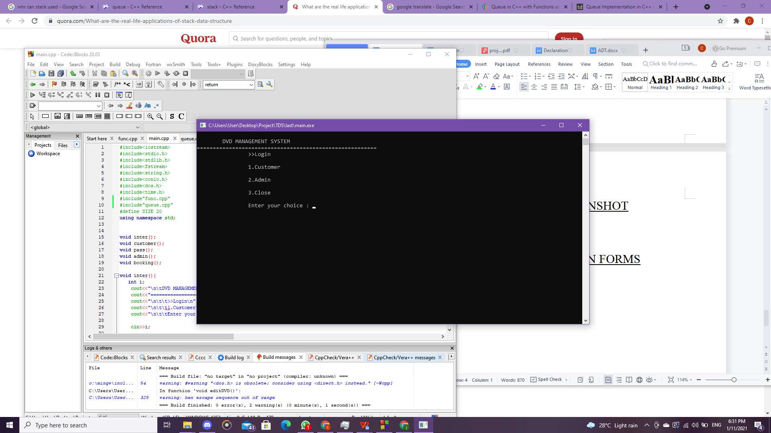

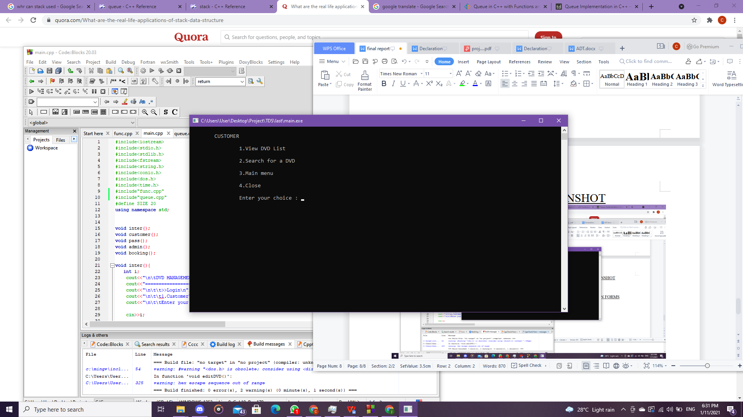

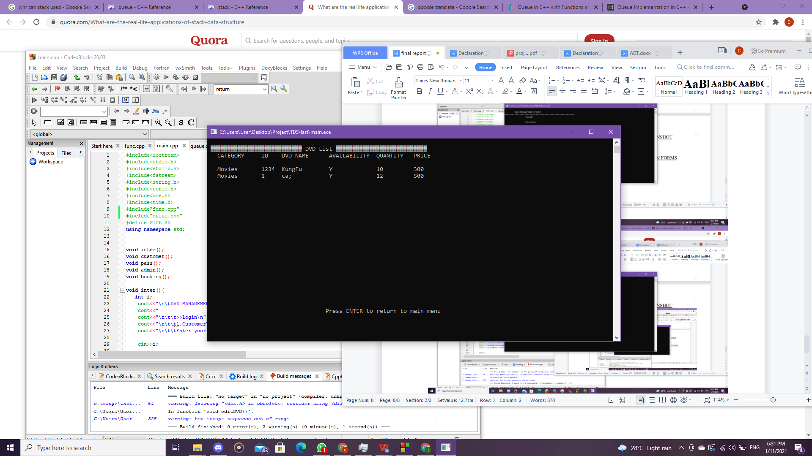

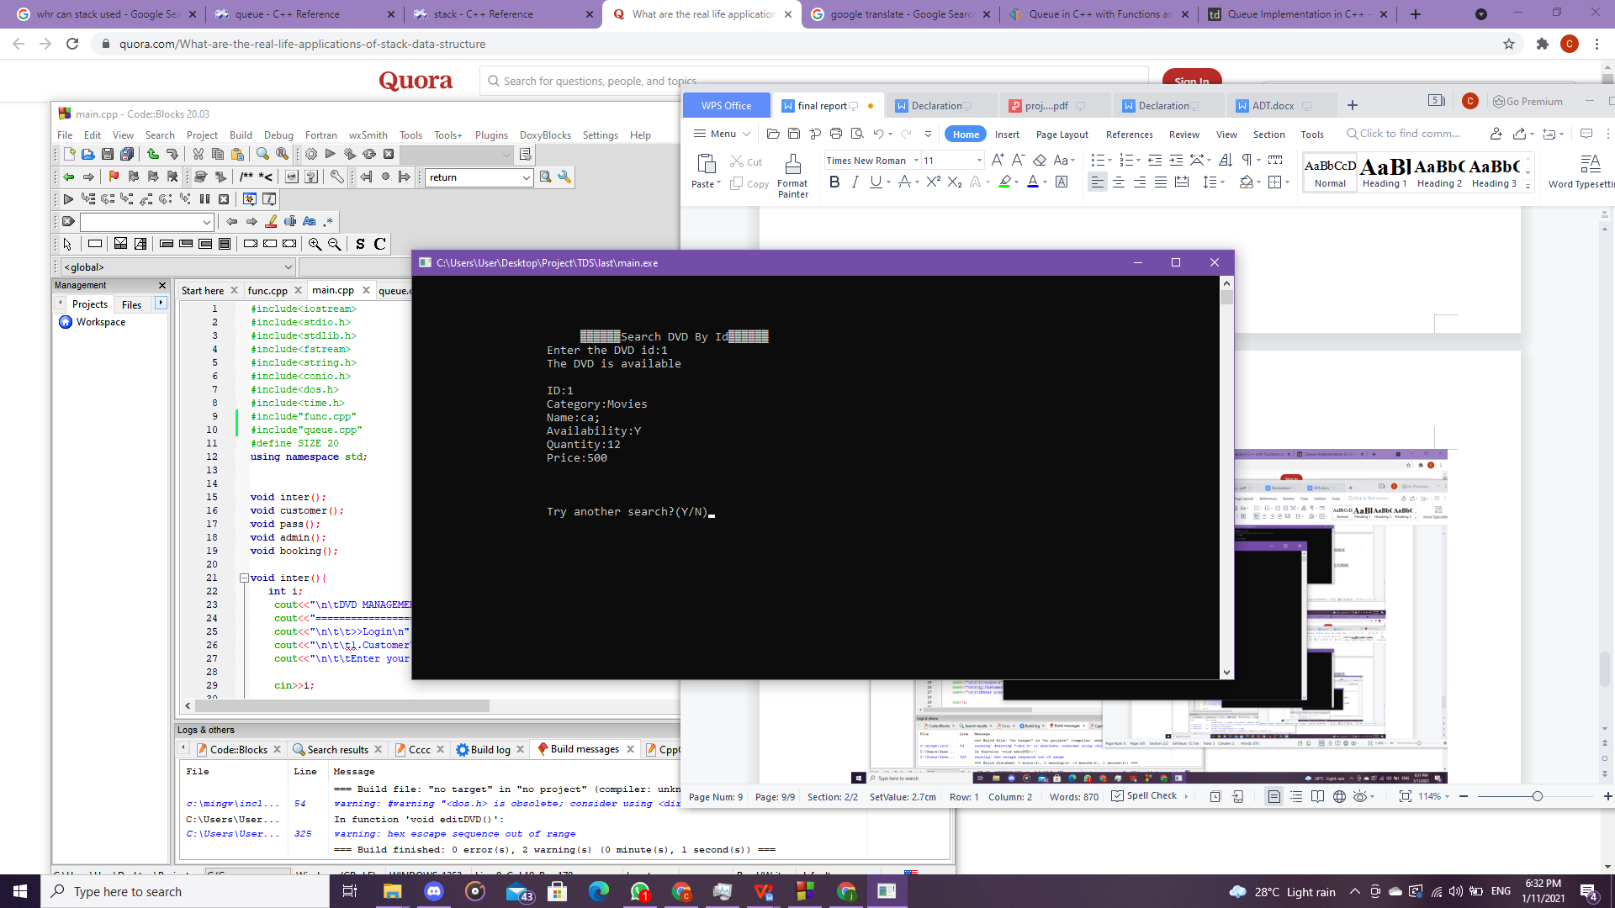

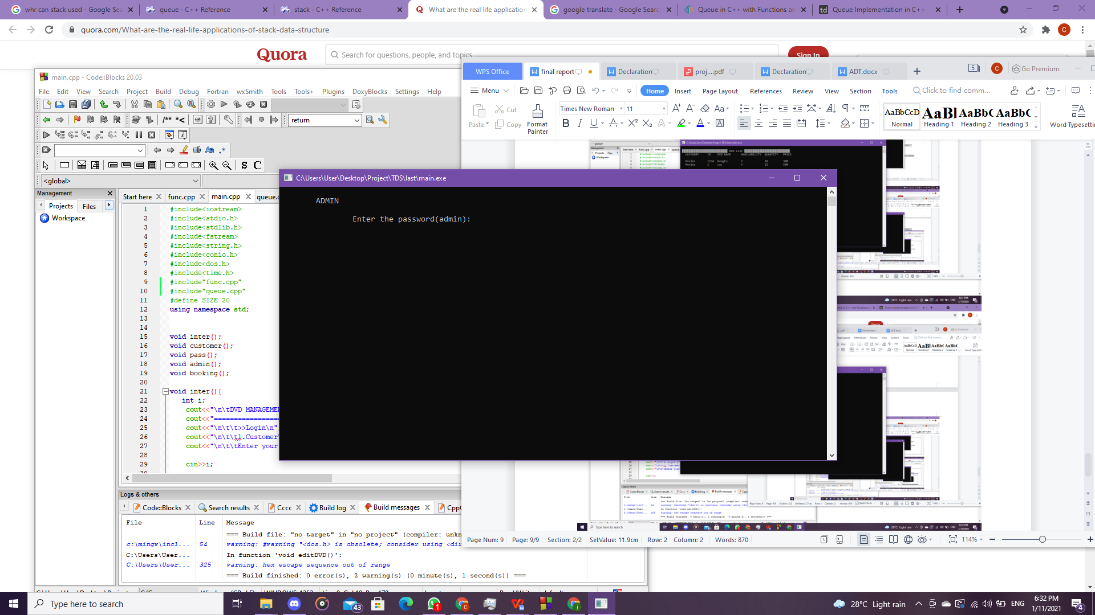

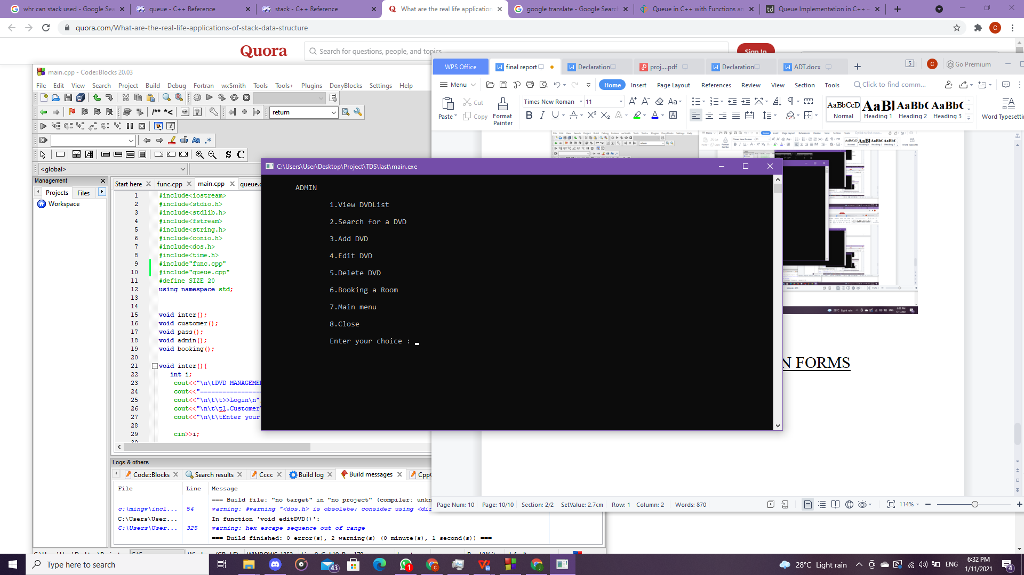

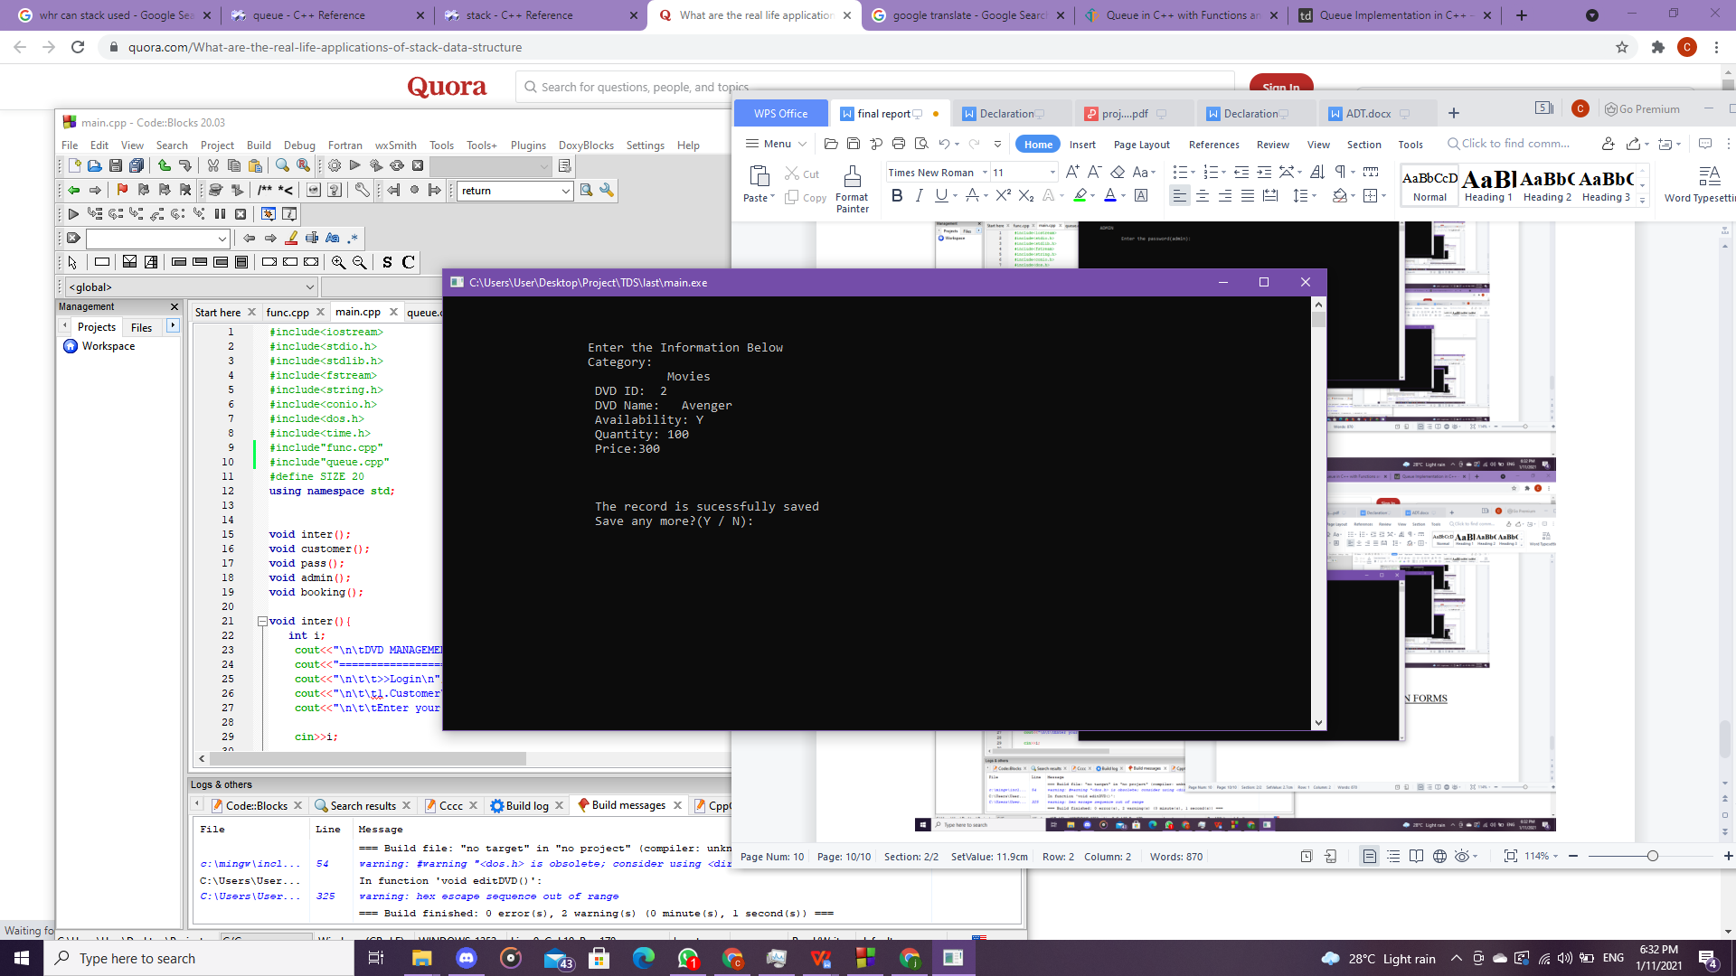

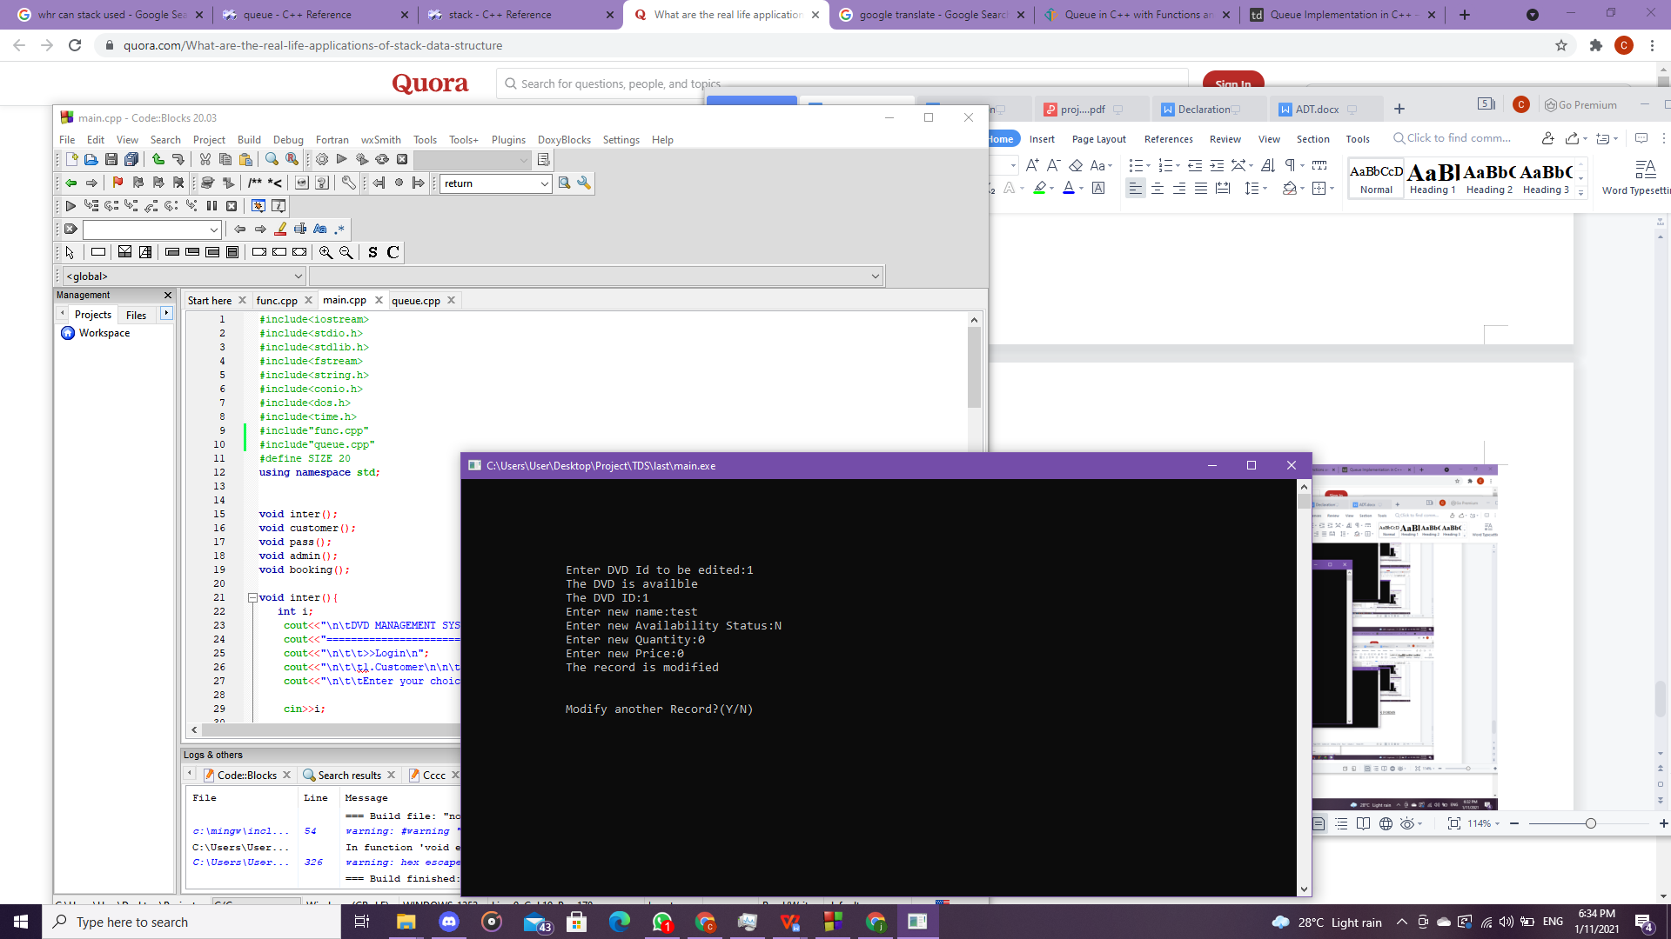

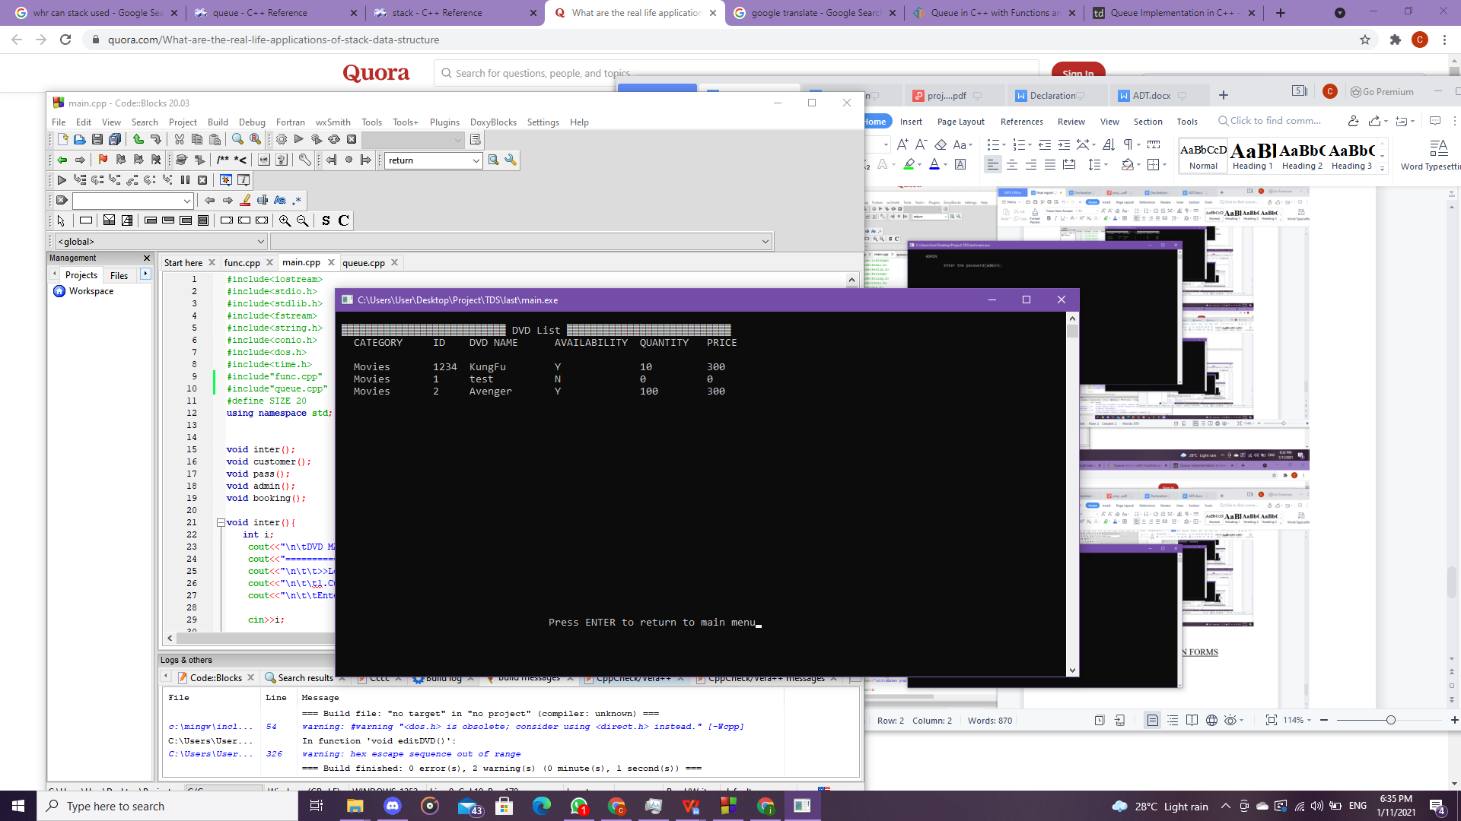

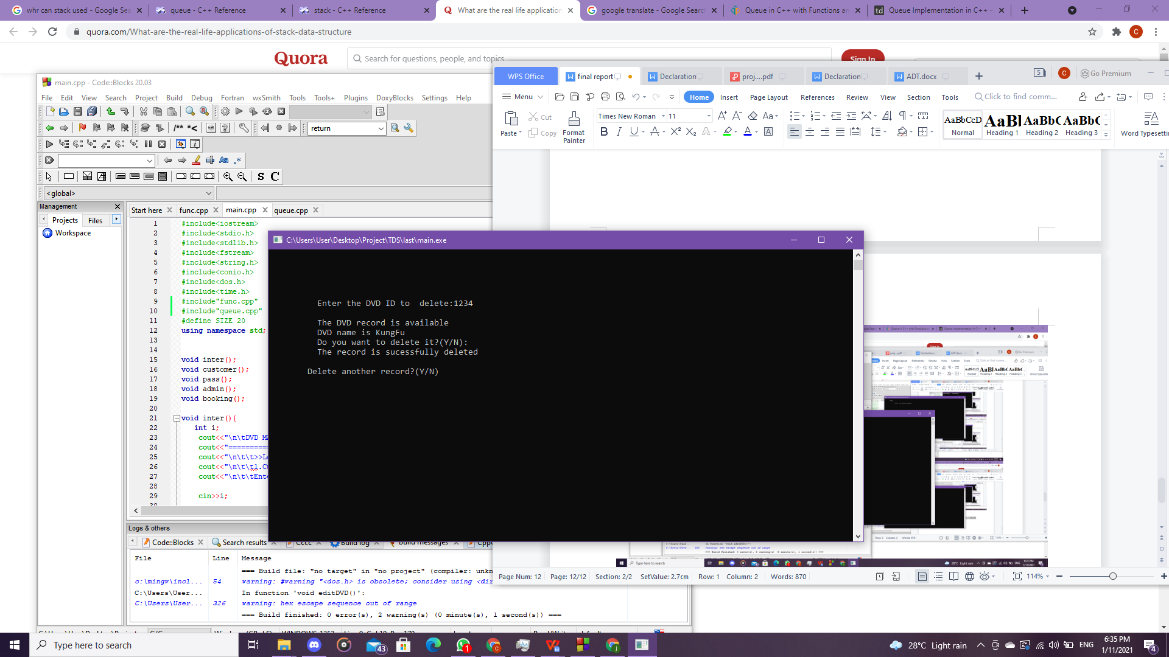

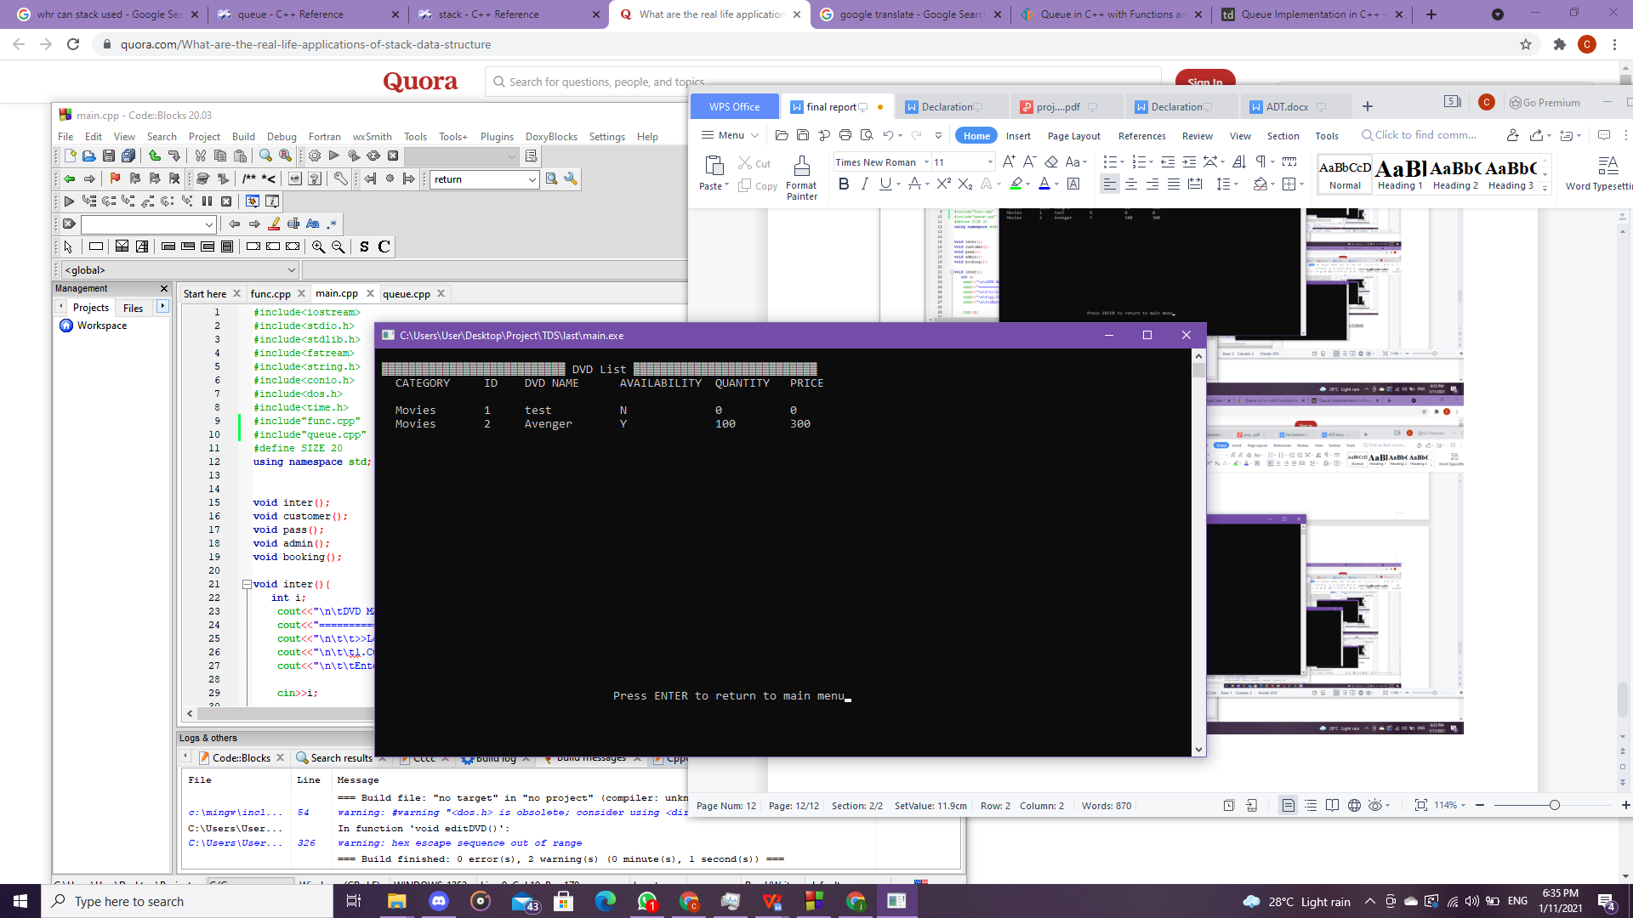

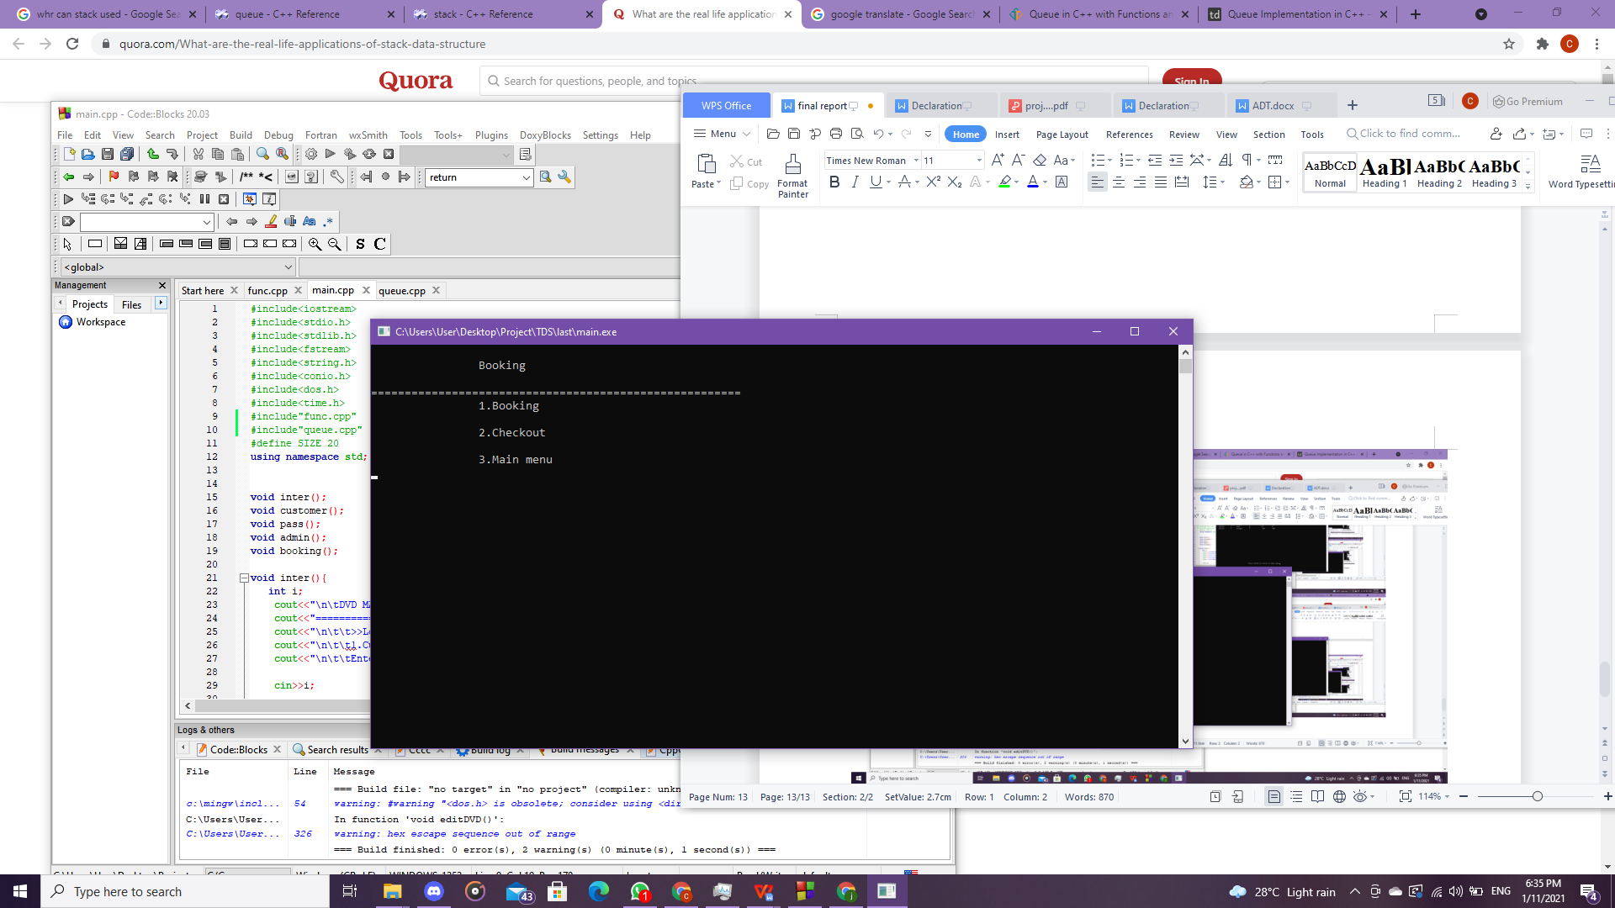

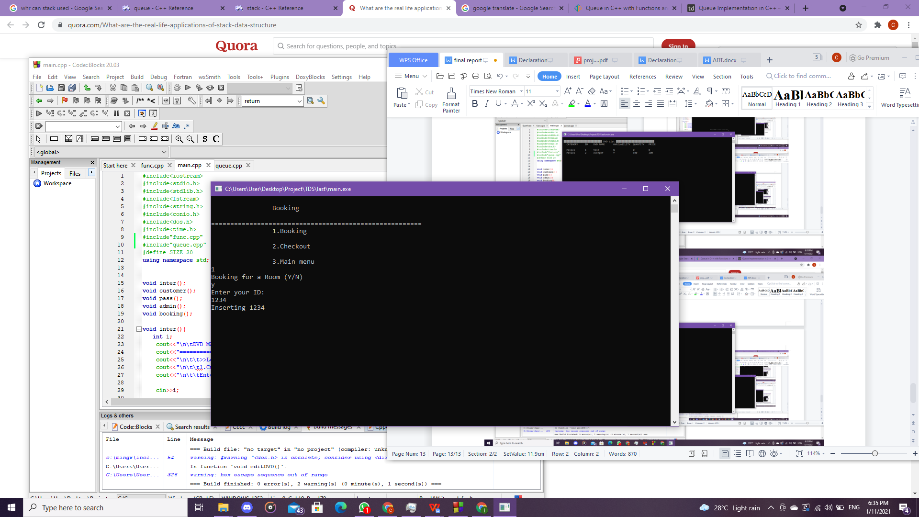

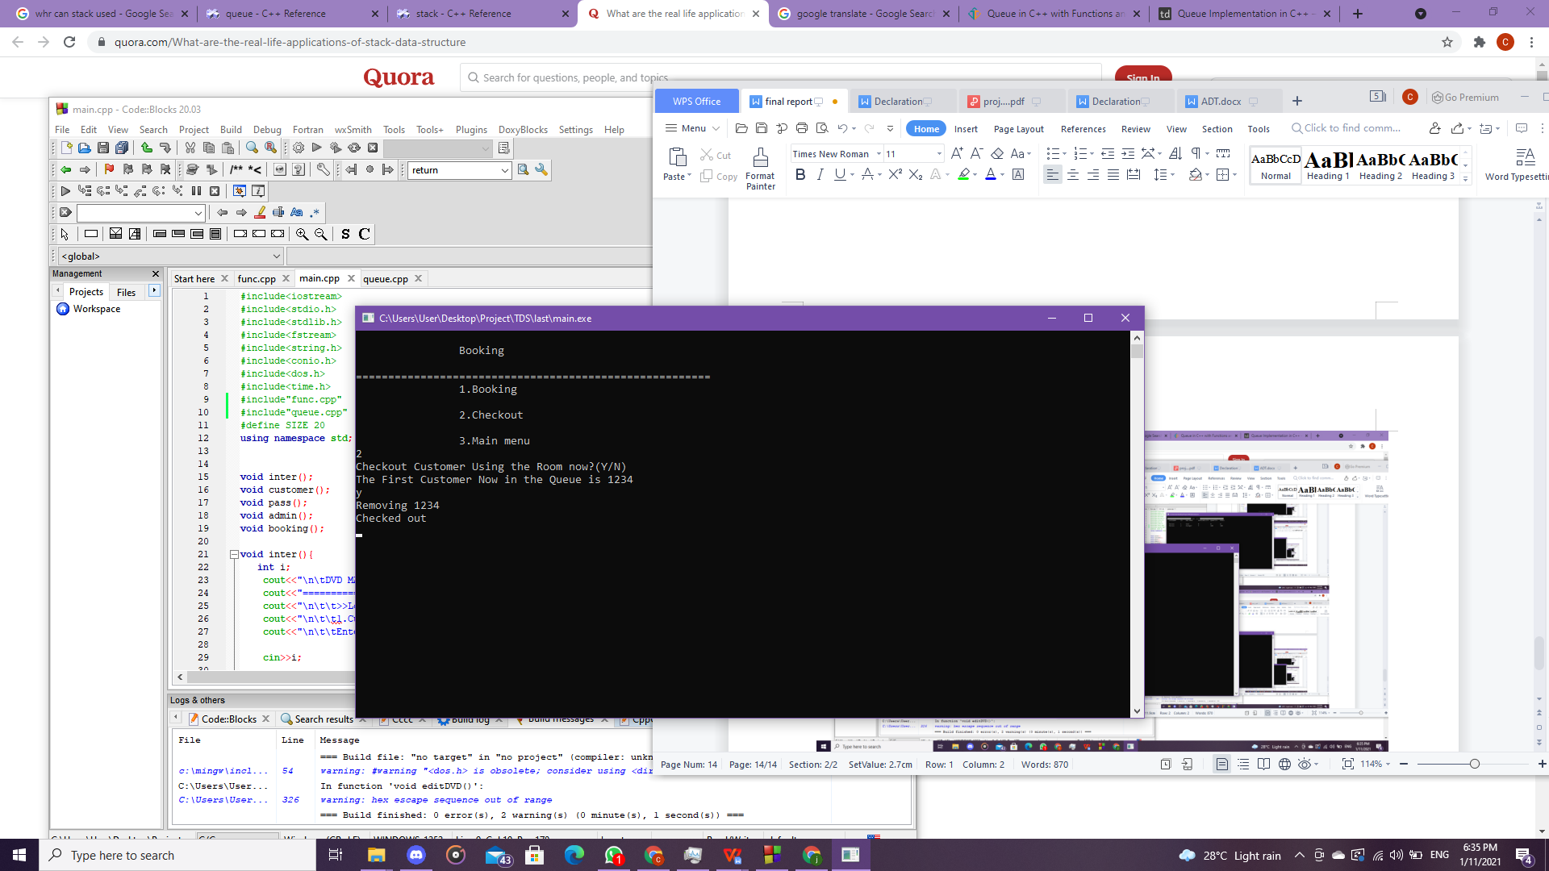

6.0 TASK DECLARATION FORMS

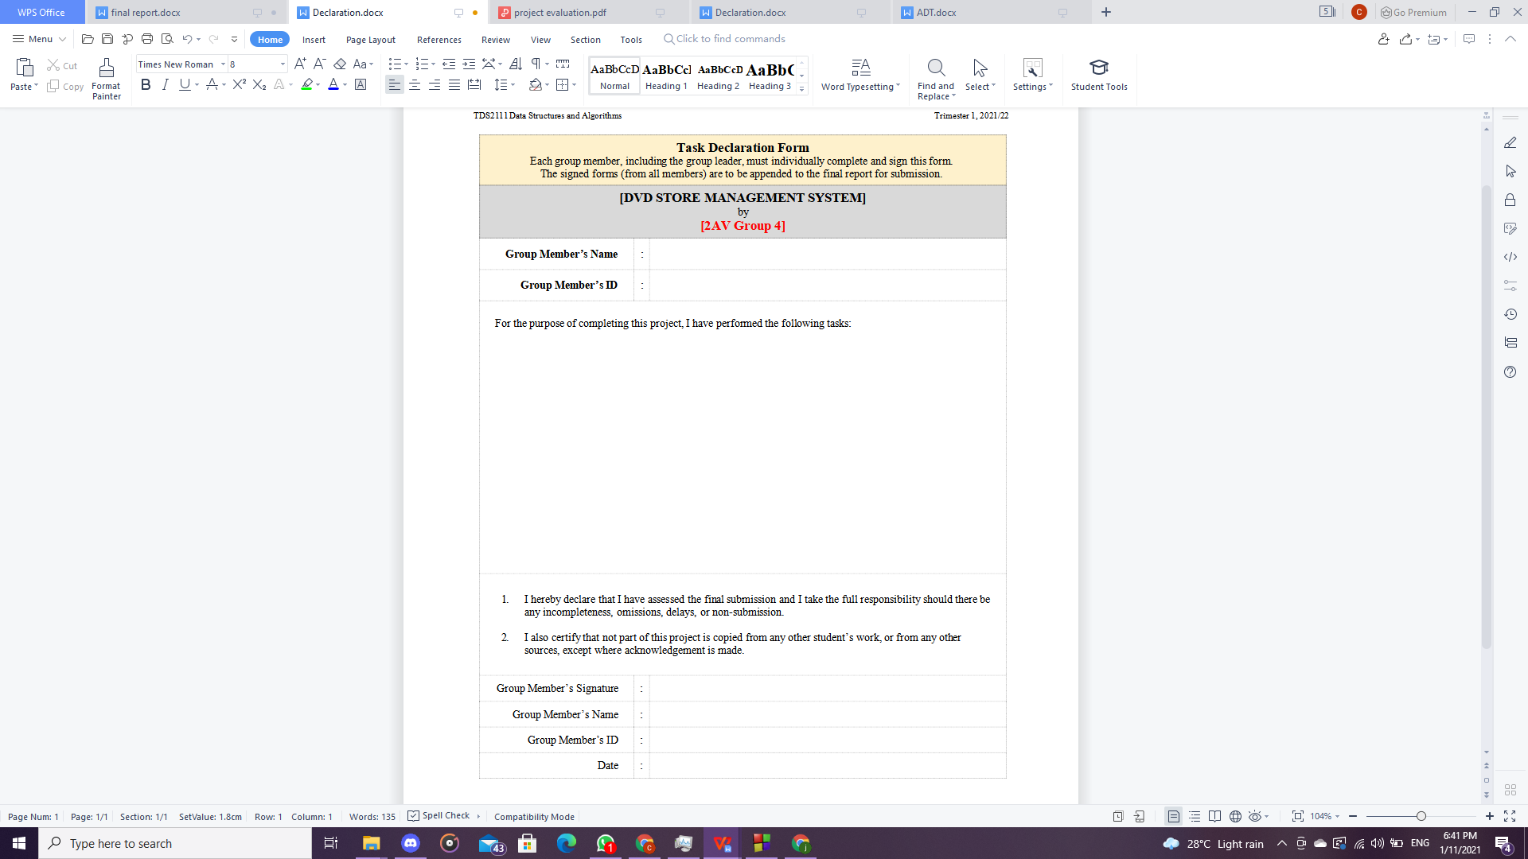

1/11/2021

1201300548

CHEONG

CHEONG JI XIANG

Doing some code and compile all the code to one,

Discuss about all the information with member,

Finalize the report

1201300548

CHEONG JI XIANG

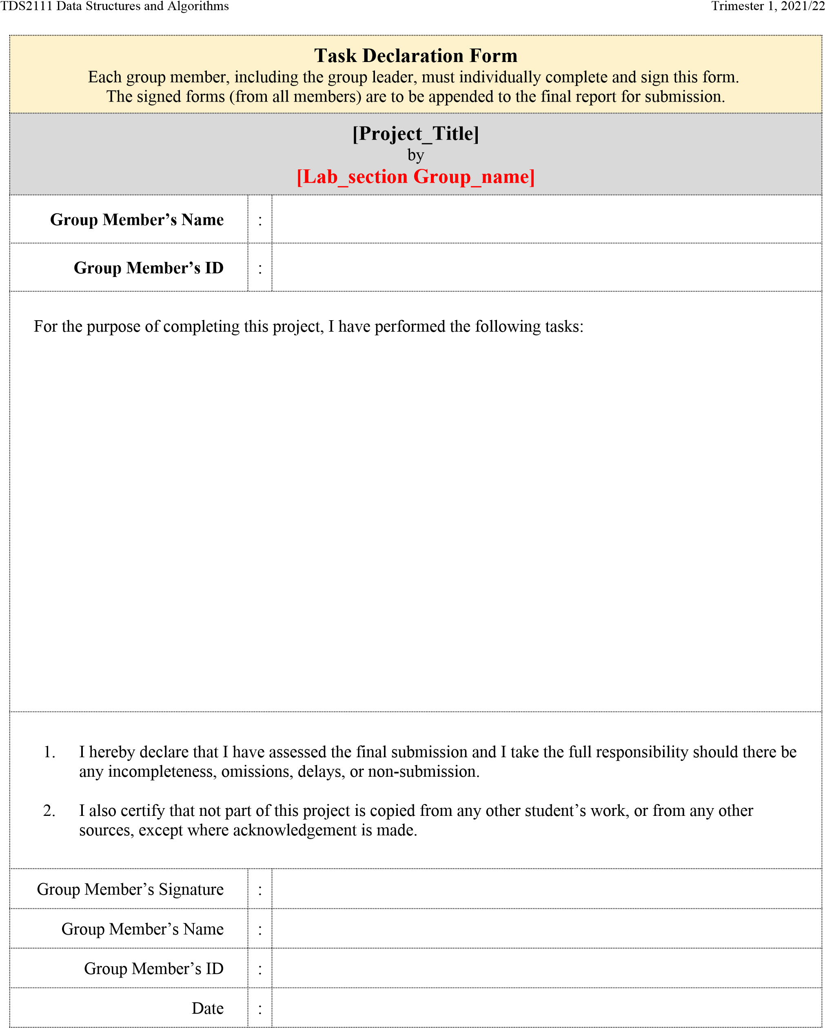

1/11/2021

1161101298

Tan Kai Chong

Tan

Discuss with group member.

Solve the code.

1161101298

Tan Kai Chong